HK Goldwing Slick 540 68”
Installing the Horizontal Stabiliser and Elevator
Preparations:
- Fit the main wings to the fuselage including the joiner tube and fastening the thumb screws in place.
- Place the plane in a nice sturdy stand in which it is held firmly against rotating about its longitudinal centreline.
- Take some 3x10mm balsa strip and cut at least 8 pieces 50mm long. Then put a 30mm taper (3mm to nothing) on one end of each piece – use your disc sander for this. These are called the shims.
- Understand that the elevator, which comes as a single completed item, must be inserted into the hole in the rudder post (HIRP) before the stabiliser is glued into place!! NOTE: The stabiliser is the unmoving part of the tail plane – that part glued to the rudder post.
- In my particular case I found I had to slide the elevator into the HIRP upside down – it only just fits through the hole! Then you rotate it to upright.

Fitment Tests:
- Slide the stabiliser into the HIRP.
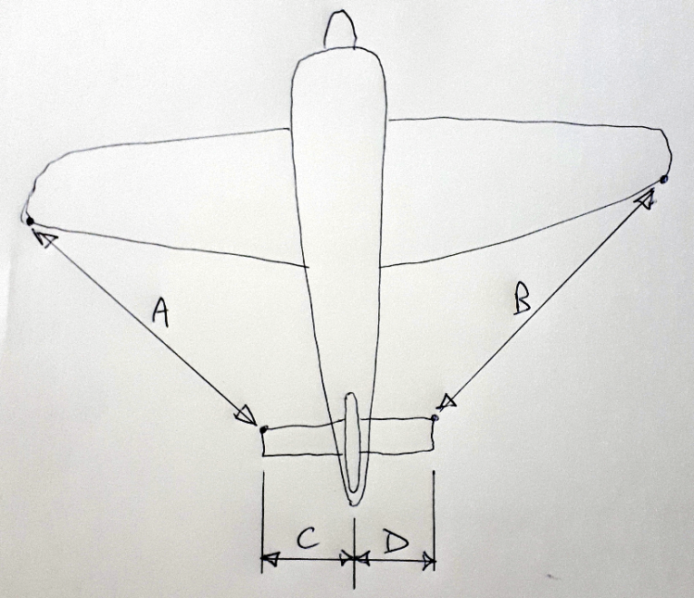
- Push shims into the gaps between the stab and HIRP until the stab is held reasonably firmly.
- Taking measurements very carefully and a few times over, make sure A = B and C = D to within a couple of millimetres. Take your time with this!
- No gluing yet!!
- Take a sharp pencil and lightly draw lines (on the stab’s film) both sides of rudder post and top and bottom of the stab up against the rudder post. You are marking approximately where to cut the film away.
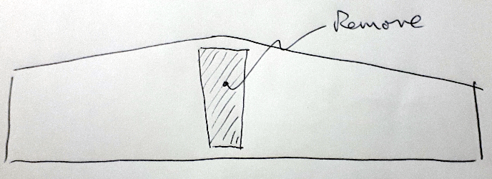
- Remove the stab from the fuselage and, using a very sharp knife, lightly cut the stab film 2mm inboard of your pencil lines. There is no need to cut the film away from the front and back sections of the stab. So, limit your cuts to about 5mm from the front and back of stab. Make joining cuts from side to side to result in approximately rectangular removal pieces. See at right.. You should have bare balsa showing where the film is removed, top and bottom of the stab.
Final Fitting:
- I am assuming at this stage that:
  - No hinges have been glued in place yet!
  - The film is ironed down sweetly on both stab and elevator.
  - The hinge holes have been tested for hinge fitment.
  - The elevator fit to the stabiliser has been tested.
- Iron down the remaining edges of film on the stab.
- Slide the elevator (possibly upside down) through the HIRP. Rotate it to upright.
- Slide the Stab roughly into place.
- Use a few hinges to connect the elevator to the stabiliser and tape the two together so they function as one piece. Put tape over and around the slots between the ends of the stab and the overlapping parts of the elevator.
- Use the same method as above (shims and measuring) to firmly hold the stab in the correct place.
- Now adjust the degree of shim insertion until, not only are A = B and C = D but, the whole tail plane is parallel to the main wings!! Very important. You will mess around with this for a while, moving shims and measuring and sight checking for parallel…..
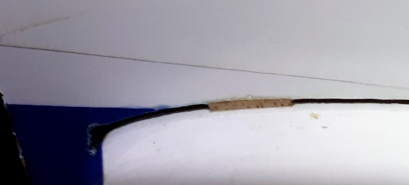
- Do not apply glue yet!
- When you are very happy with all alignments, use a very sharp knife (eg: new snap off blade) to carefully cut the shims – without moving them - away where they protrude from the HIRP.
- After one last measurement and sight check, you can apply the thin CA to the shims. The glue will wick into the shims and join the stab to the HIRP. You may also add some medium CA to the rest of the stab/HIRP joint.
Finishing off:
- Make sure all the hinges have been installed.
- Complete joining of the elevator to the stab by thin CA-ing the hinges.

I hope that covers it for you……

